**Covid Vaccine Analysis**

import pandas as pd

import numpy as np

import matplotlib.pyplot as plt

import seaborn as sns

from sklearn.model_selection import train_test_split

from sklearn.preprocessing import StandardScaler

from sklearn.linear_model import LinearRegression

from sklearn.ensemble import RandomForestRegressor

from sklearn.metrics import mean_squared_error, r2_score

import plotly.express as px

url = "https://raw.githubusercontent.com/owid/covid-19-data/master/public/data/vaccinations/vaccinations.csv"

df = pd.read_csv(url)

df['date'] = pd.to_datetime(df['date'])

df = df[df['total_vaccinations'].notna()]

df = df[df['iso_code'].apply(lambda x: len(x) == 3)]

df = df.groupby(['location', 'date']).agg({

    'total_vaccinations_per_hundred': 'max',

    'people_fully_vaccinated_per_hundred': 'max',

    'daily_vaccinations_per_million': 'mean'

}).reset_index()

latest = df.sort_values('date').groupby('location').tail(1)

latest = latest.dropna()

plt.figure(figsize=(10,6))

sns.histplot(latest['people_fully_vaccinated_per_hundred'], bins=30, kde=True)

plt.title("Distribution of Fully Vaccinated People per 100")

plt.xlabel("People Fully Vaccinated per 100")

plt.ylabel("Frequency")

plt.show()

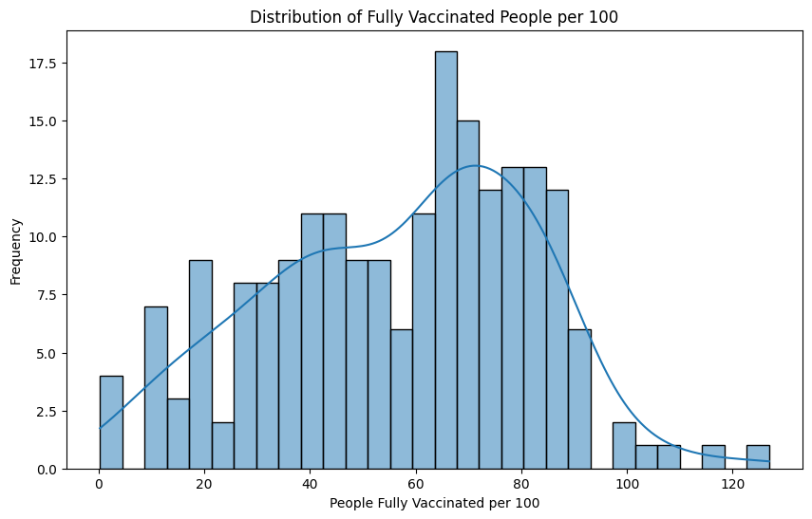

fig = px.scatter(latest, x='total_vaccinations_per_hundred', y='people_fully_vaccinated_per_hundred', hover_name='location')

fig.update_layout(title="Total vs Fully Vaccinated per 100")

fig.show()

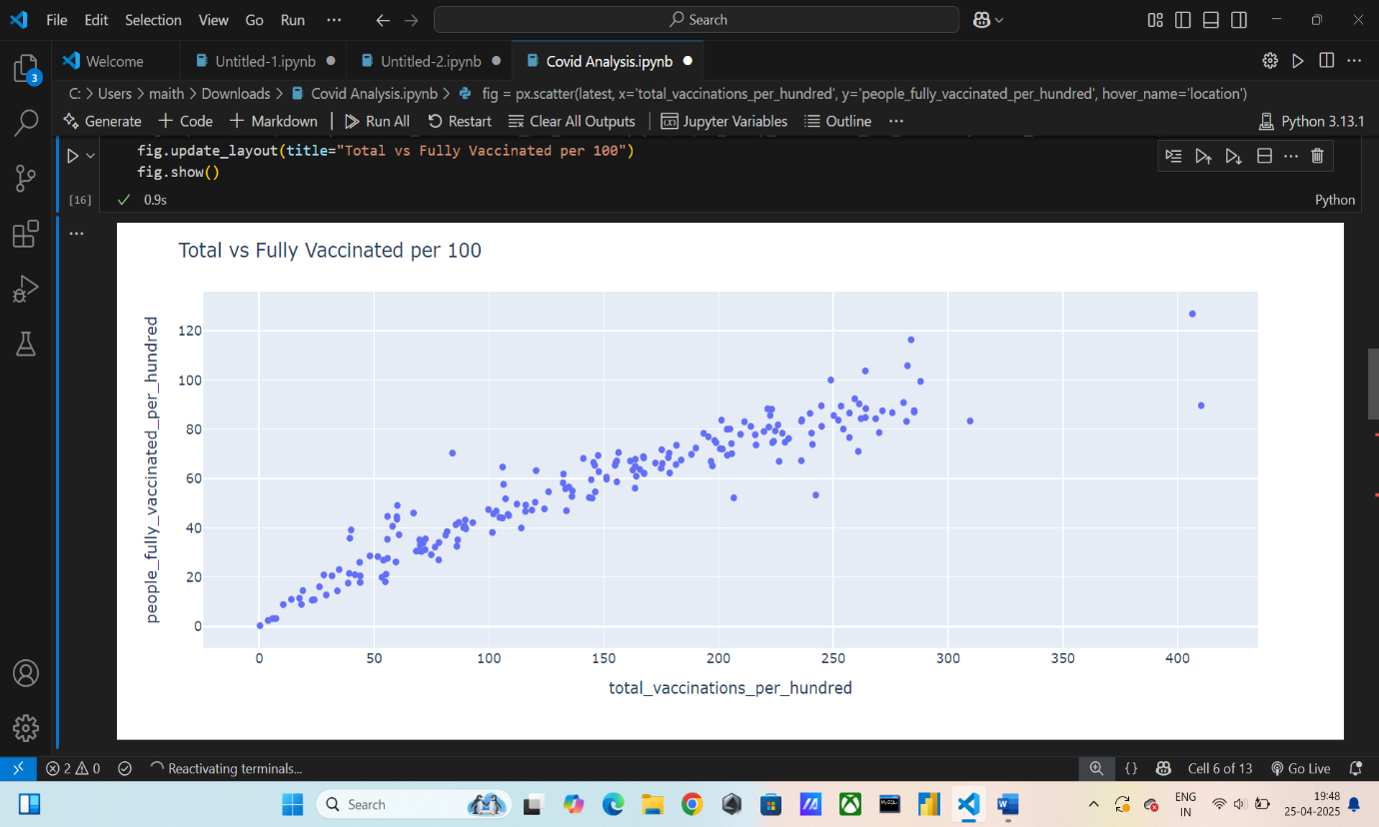

X = latest[['total_vaccinations_per_hundred', 'daily_vaccinations_per_million']]

y = latest['people_fully_vaccinated_per_hundred']

X_train, X_test, y_train, y_test = train_test_split(X, y, test_size=0.2, random_state=42)

scaler = StandardScaler()

X_train_scaled = scaler.fit_transform(X_train)

X_test_scaled = scaler.transform(X_test)

model = RandomForestRegressor(n_estimators=100, random_state=42)

model.fit(X_train_scaled, y_train)

y_pred = model.predict(X_test_scaled)

importances = model.feature_importances_

feature_names = X.columns

feat_imp_df = pd.DataFrame({'Feature': feature_names, 'Importance': importances}).sort_values(by='Importance', ascending=False)

sns.barplot(x='Importance', y='Feature', data=feat_imp_df)

plt.title("Feature Importance")

plt.show()

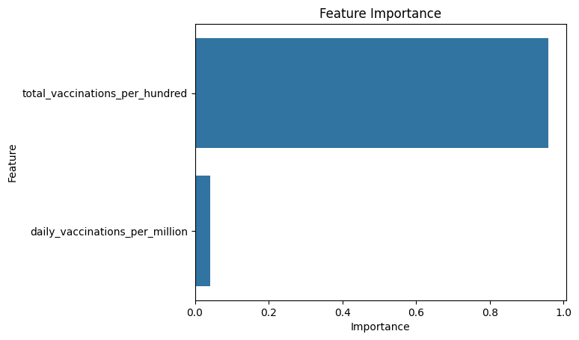

import joblib

joblib.dump(model, 'vaccination_model.pkl')

joblib.dump(scaler, 'scaler.pkl')

O/P:

['scaler.pkl']

print("\nTop Insights:")

print("- Countries with higher total vaccinations per hundred tend to have higher fully vaccinated rates.")

print("- Daily vaccination rate is a significant factor in full vaccination coverage.")

O/P:

Top Insights:

- Countries with higher total vaccinations per hundred tend to have higher fully vaccinated rates.

- Daily vaccination rate is a significant factor in full vaccination coverage.